Database project
Topic: Hotel Reservation System
Final Technical Report

Name:Javeria Javaid
Rollno:Bcsf24a041

- Abstract
This Final Technical Report provides a comprehensive design, development, implementation, and testing of the Hotel Reservation System database project. The report focuses on gathering all developed deliverables-D1 (Conceptual & Logical Design), D2 (Normalization and Physical Implementation), and D3 (Stored Logic, Complex Queries, and Testing)-into a formal academic document. The objective of the project was to create an appropriate normalized, constraint-enforced database that would be capable of maintaining hotel operations, such as reservations, guests, rooms, payments, and services. The work strongly adheres to all the requirements of the DB Final Project rubric, regarding the creation of an ERD; the creation of a schema; normalization up to 3NF/BCNF, where appropriate; full DDL/DML scripts; stored procedures; triggers; indexes; views; and ten complex SQL queries. Besides, in this report, the technical challenges faced during the development process and the solutions applied will be discussed.

2. Introduction
The Hotel Reservation System is designed to automate and streamline core operations of a hotel by providing a structured, reliable, and optimized database backend. The system is responsible for guest registration, room reservation, billing, service management, and administrative operations. This report documents the complete lifecycle of the database project-from conceptualization to final testing-following all the requirements of academic and technical standards. The report integrates design documents, SQL scripts, stored logic components, and test results into one comprehensive technical report.
3. Project Objectives & Scope
Objectives:
• Designing a normalized and efficient database schema to support hotel operations.
• Enforcing business rules, using constraints, stored procedures, and triggers.
•To populate the database with diverse, meaningful data for testing.
• To implement complex SQL queries addressing realistic business scenarios.
• Ensure system reliability for data integrity, performance, and scalability.

Scope:
The project covers:
• Conceptual and logical design: ERD, functional and non-functional requirements, business rules.
• Normalization up to 3NF/BCNF for all entities.
• Implementation of the physical schema using SQL - DDL & DML:
• Development of stored procedures and triggers that enforce system logic.
• Index and view creation to boost performance and usability.
• Validation of designs and the execution of test scripts, error handling included.
• Documentation of challenges, solutions, and project reflection.
4. Deliverable 1 (D1): Conceptual & Logical Design
4.1 Entity-Relationship Diagram (ERD)
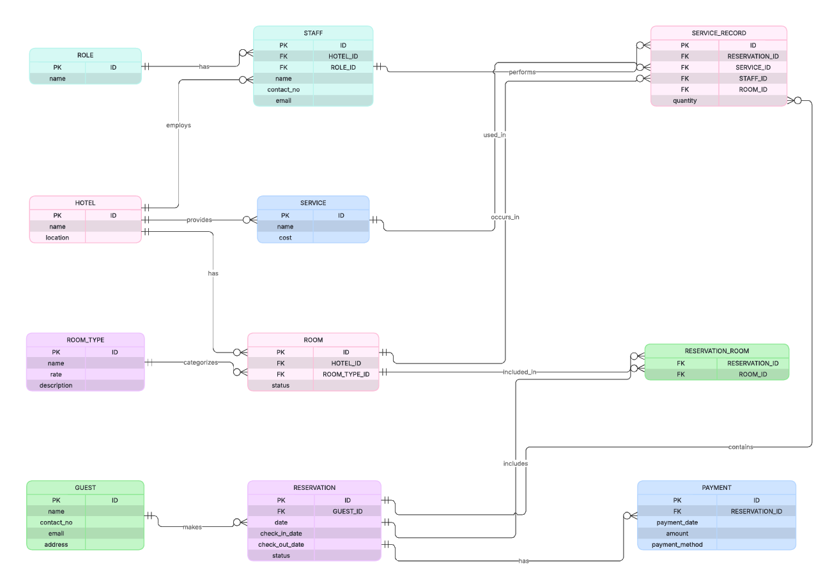
This ERD gives the core hotel operations. The major entities are Guest, Room, Reservation, Payment, RoomType, Staff, Service, ServiceRecord, and associated relationship tables. The ERD captures cardinalities, participation constraints, primary and foreign key relationships, and key business dependencies. This conceptual model forms the foundation for all further design and implementation activities.
4.2 Functional Requirements
Based on functional, nonfunctional, business rules.docx, the functional requirements would be as follows:
•Guest registration and profile management.
•Searching and booking available rooms.
•Overseeing check-in and check-out procedures.
• Record and retrieve reservation details.
• Payment processing and billing summaries.
•Ordering and allocating hotel services to rooms.
•Updates the status of rooms: available, reserved, occupied, under maintenance.
•Staff management and accomplishment of assigned operational tasks.
4.3 Non-Functional Requirements
The system adheres to the following critical non-functional requirements:
•Reliability: constraining and triggering ensure consistency of data.
• Performance: Implying of indexes for speedy query execution.
• Scalability: Modular schema design supporting future expansion.
• Security: Controlled access, validation, and integrity constraints.
• Usability: Clear, well-structured representation of hotel operations.
• Maintainability: A normalized schema that allows for easy modification.
4.4 Business Rules
Key business rules include:
• There can be only one guest reserving a room for a specific time interval.
• Payments should relate to valid reservations.
• A ServiceRecord must reference a Service and a valid Reservation.
• Room status should update in case of reservation confirmation or cancellation.
• A guest cannot check in without a valid, paid reservation.
•Staff should be part of a valid role category.
4.5 Relational Schema
The relational schema obtained from the ERD assigns:
- Primary keys for all entities.
- Foreign keys that relate reservations to guests and rooms.
- CHECK, NOT NULL, UNIQUE constraints where applicable.
- Reference tables such as RoomType and Role provide category definitions.
This schema establishes a strong logical to physical mapping that ensures referential integrity.
5. Deliverable 2 (D2): Normalization & Database Build Scripts
The second stage of the project consisted of turning the conceptual and logical design into a fully normalized, physically optimized physical database model. All files were analyzed and included in this section. This deliverable ensures that the database schema is normalised to industrial standards, structurally sound, and ready for implementation.
5.1 Normalization Report Summary
The Normalization Report follows the systematic normalization of all major entities to Third Normal Form, or 3NF, and in specific cases BCNF, where functional dependencies required stricter decomposition. Normalization confirms:
• Removal of partial dependencies 2NF
• Removal of transitive dependencies (3NF)
• Assignment of appropriate primary keys
• Assurance that each attribute depends on the key, the whole key, and nothing but the key
The analysis also checks that all the relationship tables correctly resolve many to many relationships and are devoid of any redundant or repeating groups. Therefore, the final schema would minimize redundancy, avoid anomalies, and would improve data integrity.
Normalization in the Proposed Database
During the normalization of the hotel management system ERD, the following steps were applied to the schema to ensure it meets the requirements of 3NF:
✔ Removing Derived Attributes
These included two derived attributes:
1.total_amount in RESERVATION
2. total_cost in SERVICE_RECORD
These are values that can be computed dynamically depending on related tables; for example, room rates, quantities of services, and costs therefore storing such attributes would introduce redundancy and update anomalies. They were eliminated in order to maintain 3NF compliance.

5.2 DDL Script Summary
The Data Definition Language or DDL scripts will implement the complete physical schema derived from the ERD and normalization process. The DDL scripts:
•Design all main entities like Guest, Room, Reservation, Payment, Staff, Service, ServiceRecord, RoomType, Role, and the junction tables.
• Define Primary Keys, Foreign Keys, UNIQUE constraints, CHECK constraints, NOT NULL constraints and referential actions.
• Provide good referential integrity by using cascading rules wherever applicable.
• Enforce domain integrity through data type definitions and value restrictions.
The DDL script thereby converts the logical model into an executable database structure consistent with industry-grade design standards.
Example:
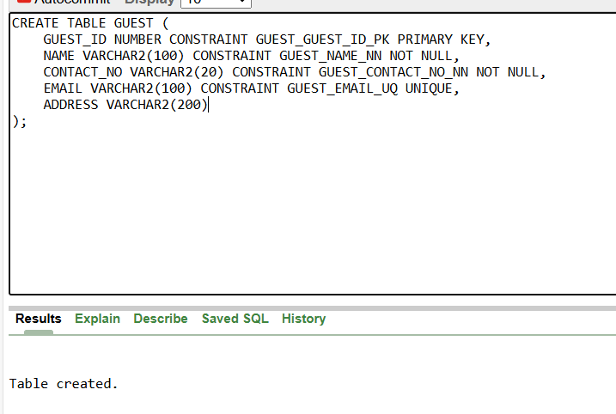
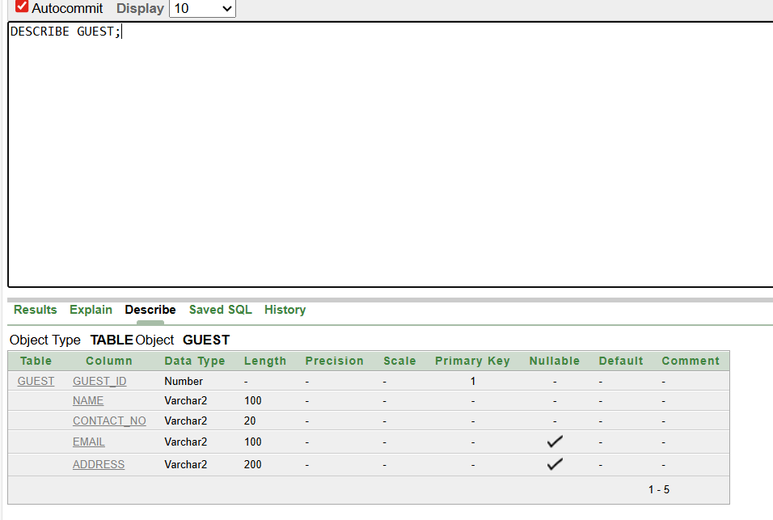

5.3 DML Script Summary (Data Population)
The DML section populates the database with meaningful and varied data. According to the requirements of the project, the dataset contains more than 50 rows of populated data for all the core tables. The data:
• It represents realistic hotel scenarios such as guest records, reservations, payments, services.
• Enables the full testing of constraints, joins, stored procedures, and triggers.
•Cover both standard and edge case values to ensure robust query behavior.
This is the base dataset for all D3 testing and for checking that stored logic and triggers are functioning properly.
Example:
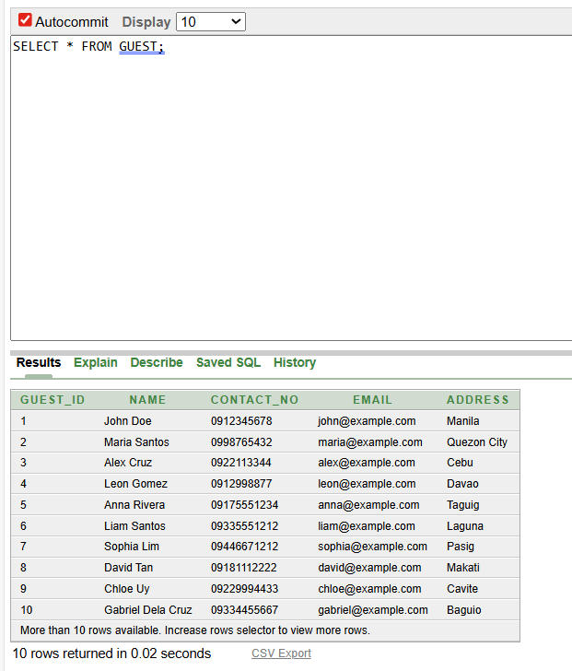

5.4 Final Database Script
The file is the complete, executable SQL file combining:
• Schema creation (DDL)
• Data insertion-DML
• Referential integrity constraints
This consolidated script will be appropriate for the deployment of the database on any SQL environment, such as Oracle, MySQL, and SQL Server. This will ensure that the instructor or evaluator can reproduce exactly the structure and contents of the whole database.
6. Deliverable 3 (D3): Stored Logic, Testing & Advanced Features
Deliverable 3 focuses on implementing advanced database mechanisms including stored procedures, triggers, sequences, indexes, views, and structured testing.

6.1 Stored Procedures
These stored procedures were created to encapsulate business logic and provide an enforcement mechanism of automated workflows within the Hotel Reservation System. The procedures included in this document will enable the system to perform controlled operations such as:
• Reservation creation validation
•Handling Payment Processing
• Dynamic update of room status
• Eligibility check for guest check-in.
Each stored procedure provides for parameterized inputs, internal validation checks, conditional logic, and meaningful exceptions for invalid operations. These procedures enhance reliability, security, and maintainability by centralizing system rules at the database level.
Example:
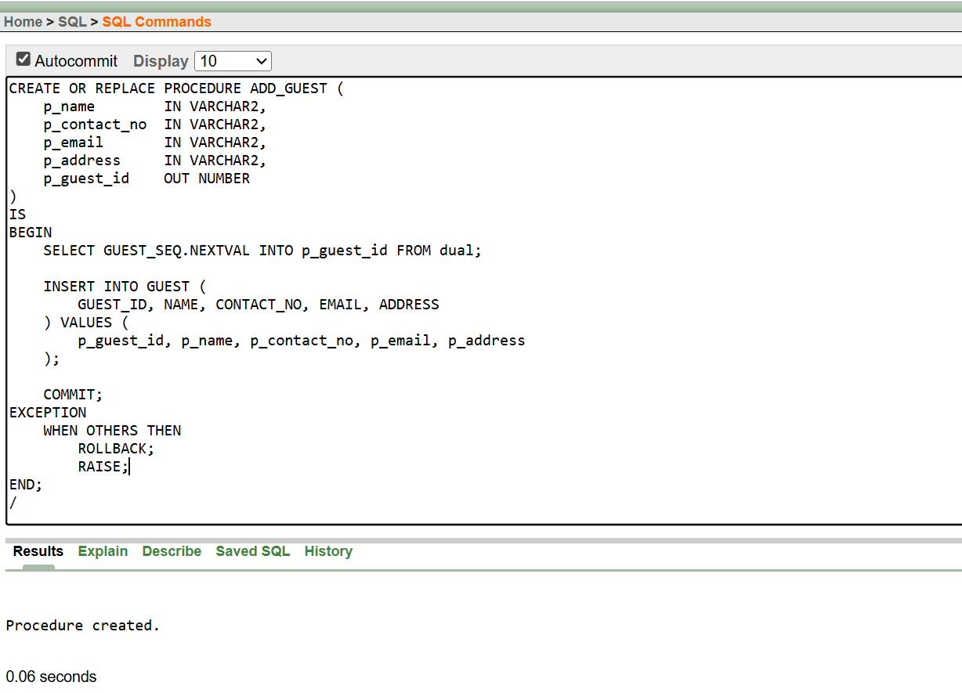

6.2 Triggers
Triggers are crucial in imposing business rules automatically when records are inserted, updated, or deleted. Included triggers for:
•Updating room status after the creation of a reservation and its cancellation
•Automatic timestamp generation
• Avoiding the creation of inconsistent reservation entries
• No check in allowed without payment
These triggers run transparently, hence providing consistency of data without application side validation.
Example:
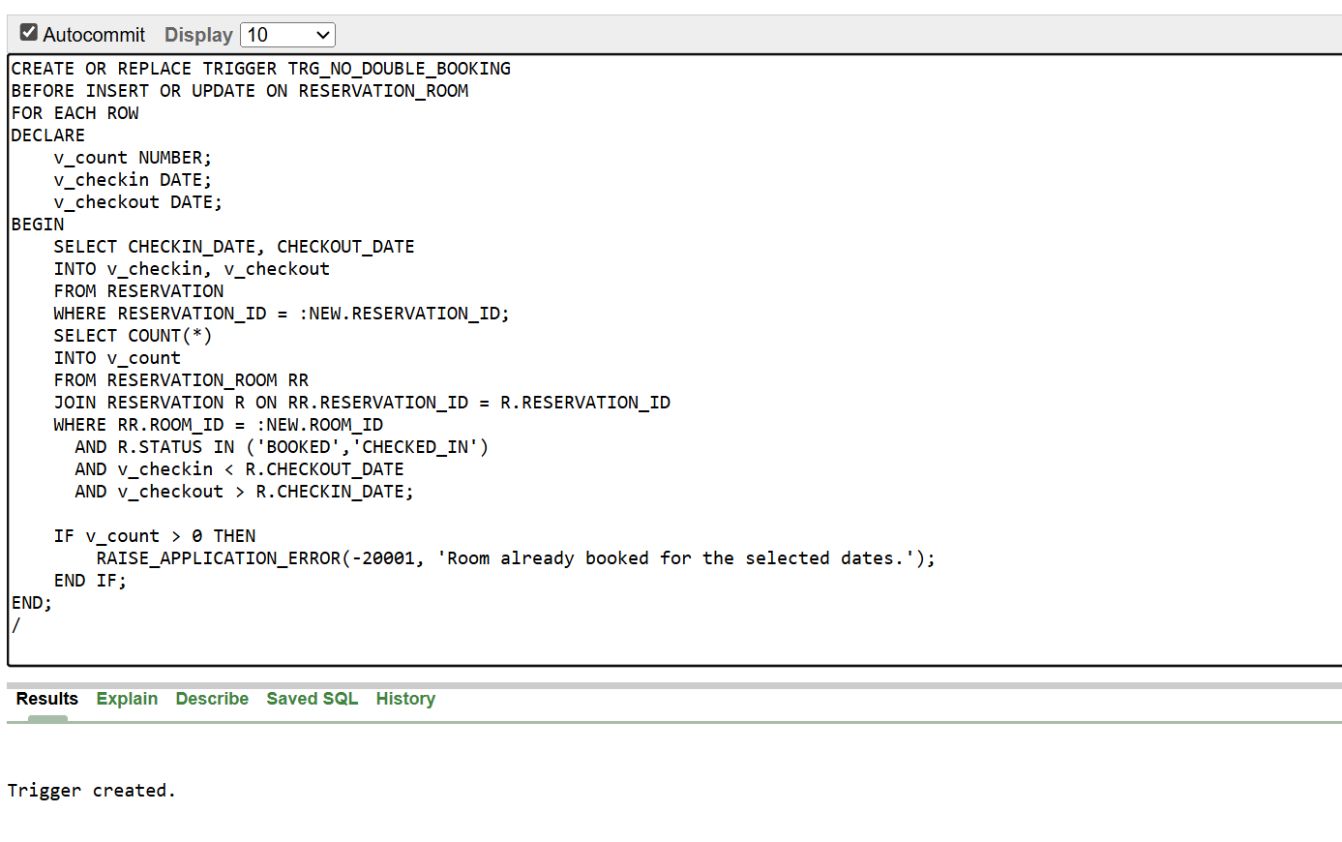

6.3 Procedures and Triggers Testing
The procedures, triggers, testing provides comprehensive test cases validating both successful operations and error handling scenarios.
Successful tests include:
• Valid reservation creation
• Add payment to an existing reservation
•Assigning a service to a valid room
•Successful check-in after payment
Example:
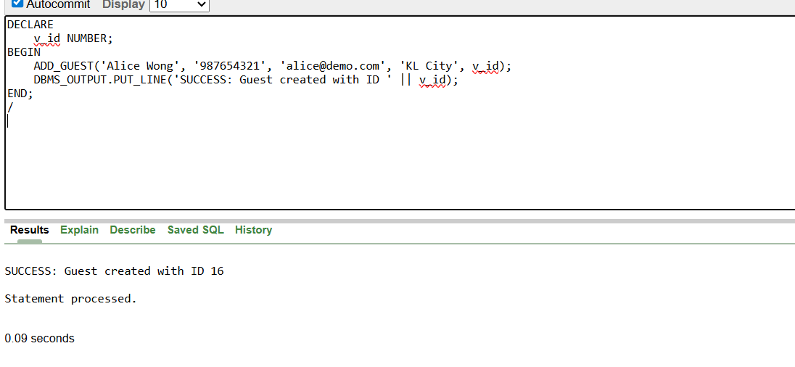
Failure Tests Include:
• Trying to book a room that is already occupied
• The creation of a reservation for a guest that doesn't exist
•Checking in without paying
• Entering invalid or null values where constraints apply
Example:
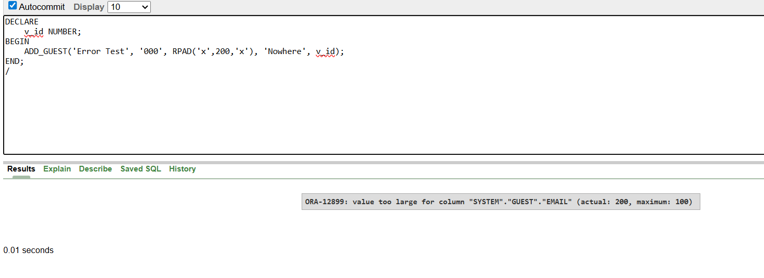
Each test demonstrates the effectiveness of constraints, triggers, and procedures in enforcing system integrity.

6.4 Indexes & Views
It defines two non-key indexes and two views, as required.
Indexes:
Indexes were created to help improve the querying process, specifically for those frequently searched fields like:
•Guest Name / Phone
• Room Status
•Reservation Date
These indexes reduce the execution time of queries drastically for huge datasets and improve the user experience.
Example:
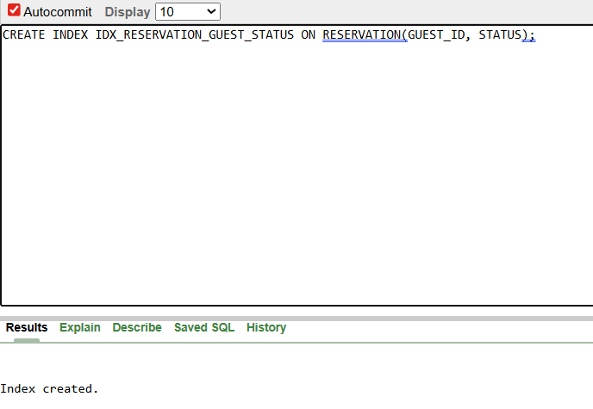
Views:
Two views were designed to simplify data retrieval for reporting and administrative tasks:
- View 1: Consolidated reservation details (guest, room, date, payment)
- View 2: Service usage summary linked with reservations
These views abstract complex joins, improve security, and support analytical reporting.
Example:
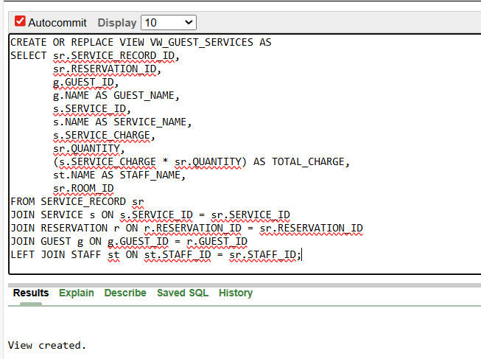

6.5 Sequences
Sequences were implemented to automate the generation of unique identifiers for entities such as reservations, staff, and payments. They ensure:
- Consistent auto-incremented values
- Prevention of duplicate IDs
- Simplification of insertion logic
Example:
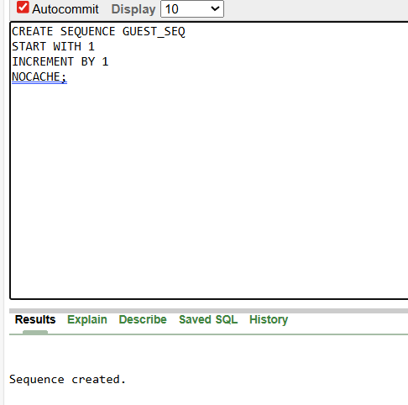

7. Complex Queries (10 Required Queries)
Ten complex SQL queries were developed to address real-world hotel management scenarios, including joins, subqueries, grouping, aggregation, analytical functions, and conditional filtering. These queries include:
- Guest reservation history
- Rooms currently available
- Monthly revenue calculation
- Most frequently booked room types
- Guests with unpaid balances
- Services used per reservation
- Staff assignment summary
- High-value customers (based on spending)
- Reservation conflicts detection
- Top 5 peak occupancy days
Example:
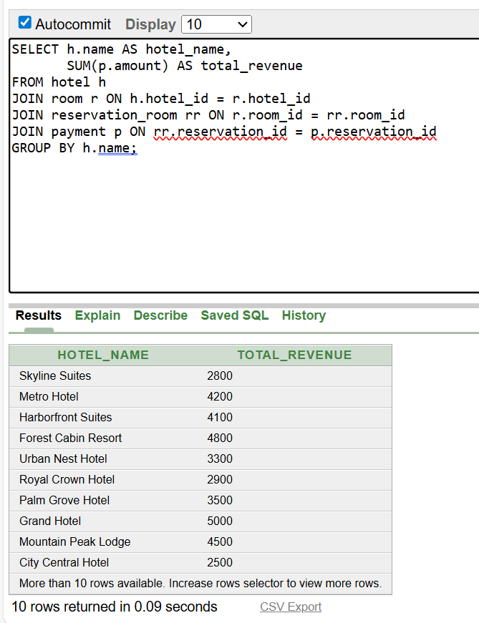
Each query demonstrates mastery of SQL logic and aligns with the project requirements.

8. Technical Challenges & Solutions
Several challenges emerged during the project, including:
- Normalization conflicts: Resolved through decomposition and functional dependency analysis.
- Trigger recursion risks: Carefully resolved through conditional logic.
- Maintaining referential integrity: Solved using cascading constraints.
- Complex join queries: Optimized using indexes and views.
Each challenge was resolved through iterative refinement of schema and logic.

9.Real-World Applications and Practical Usefulness of the Hotel Reservation System
The Hotel Reservation System developed in this project has outstanding real-world value based on the operational challenges common in hospitality management. Practically, hotels need efficient, effective, and scalable systems that can handle business activities day in and day out. This database system promotes and enhances key hotel operations with defined data storage, automation of business rules, and efficient access to information.
1.Enhanced Operational Efficiency
By automating the handling of reservations, managing guests, and coordinating services, the system cuts out manual record keeping, reduces errors, and speeds up customer-facing processes such as check-in, check-out, and billing.
2. Better Data Accuracy and Integrity
The constraints, triggers, and stored procedures ensure that the data coming in is valid, consistent, and complete. This reduces the occurrence of problems, such as double bookings, invalid payments, or wrong room statuses, which often arise in a manual operation of a hotel.
3. Real-time Availability and Decision Support
Hotel staff can view room availability, reservation details, and payment status, as well as service usage, instantly. Overbooking decisions, room assignment decisions, staff shifts, and schedules for maintenance-repairs can be quickly made by managers.
4. Financial Tracking and Reporting
This system will keep all the payment records and generate detailed revenue reports that will enable hotel management to track their financial performance, predict their revenue, and observe the time of year when the business is at its peak.
5. Service Management and Customer Satisfaction
It records every service request and can be allocated to respective reservations, so as to ensure timely delivery and proper billing. This leads to higher guest satisfaction and the yielding of better results regarding the hotel experience.
6. Scalability and Business Growth
It is designed to hold a growing number of guests, rooms, staff, and services. When a hotel expands, additional modules can be added with ease, so the system is suitable for small hotels, resorts, and even big hotel chains.
7. Security and Controlled Access
The structured schema and controlled operations provide confidentiality and prevent unauthorized modification. This is particularly critical to ensure customer information and financial data are protected.
8. Long-term maintainability
Normalization and modular schema design enable hotels to easily update prices, room categories, service catalogs, and staff roles without breaking the system. This makes it viable for extended business use.
____________________________________________________________________________________
10. Conclusion
The Hotel Reservation System database project successfully fulfills all academic requirements across Deliverables 1, 2, and 3. The final system is normalized, constraint-enforced, fully populated, and enhanced with stored logic, triggers, views, indexes, and comprehensive testing. The project demonstrates strong understanding of database theory and practical SQL implementation.

